# **Laboratory-7**

## **Question**

## Perform DAG construction and simple code generation.

### **Dag.cpp:**

#include <bits/stdc++.h>

**using** **namespace** std;

**struct** label_list

{

**char** value;

**struct** label_list *next;

};

**struct** dag_node

{

**char** value;

**int** index;

**int** label;

**int** parent_count;

**struct** label_list *labels;

**struct** dag_node *left, *right;

};

**struct** root_list

{

**struct** dag_node *root;

**struct** root_list *next;

};

**struct** three_address

{

**char** op;

**char** op1;

**char** op2;

**char** lhs;

};

**int** index_global = 0, n;

three_address tac[100];

**bool** visited_left_most_child = 0;

stack<**int**> rstack, tstack;

label_list *insert_label(label_list *curr, **char** c)

{

label_list *temp = **new** label_list;

temp->value = c;

temp->next = NULL;

**if** (curr == NULL)

{

**return** temp;

}

label_list *start = curr;

**while** (start->next)

{

start = start->next;

}

start->next = temp;

**return** start;

}

dag_node *create_dag_node(**char** op, **char** result)

{

dag_node *temp = **new** dag_node;

temp->index = index_global++;

temp->value = op;

temp->left = temp->right = NULL;

temp->labels = NULL;

temp->labels = insert_label(temp->labels, result);

**return** temp;

}

**bool** search_labels(dag_node *x, **char** value)

{

**if** (x->value == value)

{

**return** 1;

}

label_list *start = x->labels;

**while** (start)

{

**if** (start->value == value)

{

**return** 1;

}

start = start->next;

}

**return** 0;

}

**bool** check(dag_node *n1, dag_node *n2, **char** c1, **char** c2)

{

**if** (search_labels(n1, c1) && search_labels(n2, c2))

{

**return** 1;

}

**return** 0;

}

dag_node *search_for_value(root_list *root, **char** value)

{

**int** recent = -1;

queue<dag_node *> q;

dag_node *x, *result = NULL;

vector<**bool**> visited(index_global, 0);

root_list *start = root;

**while** (start)

{

q.push(start->root);

start = start->next;

}

**while** (!q.empty())

{

x = q.front();

q.pop();

visited[x->index] = 1;

**if** (search_labels(x, value))

{

**if** (x->index > recent)

{

recent = x->index;

result = x;

}

}

dag_node *left = x->left;

dag_node *right = x->right;

**if** (left && !visited[left->index])

q.push(left);

**if** (right && !visited[right->index])

q.push(right);

}

**return** result;

}

dag_node *search_for_similar(root_list *root, **char** op, **char** op1, **char** op2)

{

**int** recent = -1;

queue<dag_node *> q;

dag_node *x, *result = NULL;

vector<**bool**> visited(index_global, 0);

root_list *start = root;

**while** (start)

{

q.push(start->root);

start = start->next;

}

**while** (!q.empty())

{

x = q.front();

q.pop();

visited[x->index] = 1;

**if** (search_labels(x, op))

{

**if** (check(x->left, x->right, op1, op2))

{

**if** (x->index > recent)

{

result = x;

recent = x->index;

}

}

}

dag_node *left = x->left;

dag_node *right = x->right;

**if** (left && !visited[left->index])

q.push(left);

**if** (right && !visited[right->index])

q.push(right);

}

**return** result;

}

root_list *add_to_end(root_list *curr, dag_node *root)

{

root_list *temp = **new** root_list;

temp->root = root;

temp->next = NULL;

**if** (curr == NULL)

{

**return** temp;

}

root_list *start = curr;

**while** (start->next)

{

start = start->next;

}

start->next = temp;

**return** curr;

}

root_list *create_dag(root_list *root, **int** curr)

{

**if** (curr == n)

{

**return** root;

}

**if** (root == NULL)

{

dag_node *parent, *left, *right;

parent = create_dag_node(tac[curr].op, tac[curr].lhs);

left = create_dag_node(tac[curr].op1, tac[curr].op1);

right = create_dag_node(tac[curr].op2, tac[curr].op2);

parent->left = left;

parent->right = right;

root = **new** root_list;

root->root = parent;

root->next = NULL;

**return** create_dag(root, curr + 1);

}

**if** (tac[curr].op == '=')

{

dag_node *temp = search_for_value(root, tac[curr].op1);

temp->labels = insert_label(temp->labels, tac[curr].lhs);

**return** create_dag(root, curr + 1);

}

**else**

{

dag_node *parent = search_for_similar(root, tac[curr].op, tac[curr].op1, tac[curr].op2);

dag_node *left = search_for_value(root, tac[curr].op1);

dag_node *right = search_for_value(root, tac[curr].op2);

{

**if** (left && right && parent)

{

**if** (parent->left->index == left->index && parent->right->index == right->index)

parent->labels = insert_label(parent->labels, tac[curr].lhs);

**return** create_dag(root, curr + 1);

}

}

parent = create_dag_node(tac[curr].op, tac[curr].lhs);

**if** (left == NULL)

{

left = create_dag_node(tac[curr].op1, tac[curr].op1);

}

**if** (right == NULL)

{

right = create_dag_node(tac[curr].op2, tac[curr].op2);

}

parent->left = left;

parent->right = right;

root_list *start = root;

root_list *temp = NULL;

**while** (start)

{

**if** (start->root != left && start->root != right)

{

temp = add_to_end(temp, start->root);

}

start = start->next;

}

temp = add_to_end(temp, parent);

root = temp;

**return** create_dag(root, curr + 1);

}

}

**void** inorder(dag_node *curr, vector<**bool**> &visited)

{

curr->parent_count++;

**if** (visited[curr->index])

{

**if** (curr->left != NULL)

{

inorder(curr->left, visited);

}

**if** (curr->right != NULL)

{

inorder(curr->right, visited);

}

**return**;

}

visited[curr->index] = 1;

**if** (curr->left == NULL && curr->right == NULL)

{

cout << "Leaf with Index: " << curr->index << " ,Value: " << curr->value << " ,Label: " << curr->label << "\n\n";

}

**else**

{

cout << "Index: " << curr->index << " ,Value: " << curr->value << " ,Label: " << curr -> label << '\n';

label_list *temp = curr->labels;

cout << "Labels are: ";

**while** (temp)

{

cout << temp->value << ' ';

temp = temp->next;

}

cout << '\n';

cout << "Left child has index " << curr->left->index << '\n';

cout << "Right child has index " << curr->right->index << '\n';

cout << '\n';

inorder(curr->left, visited);

inorder(curr->right, visited);

}

}

dag_node *assign_labels(dag_node *curr, **bool** left_child, vector<**bool**> &visited)

{

**if** (visited[curr->index])

{

**return** curr;

}

visited[curr->index] = 1;

**if** (curr->left == NULL && curr->right == NULL)

{

**if** (!left_child)

{

curr->label = 0;

}

**else**

{

curr->label = 1;

}

**return** curr;

}

curr->left = assign_labels(curr->left, 1, visited);

curr->right = assign_labels(curr->right, 0, visited);

**if** (curr->left->label == curr->right->label)

{

curr->label = curr->left->label + 1;

}

**else**

{

curr->label = max(curr->left->label, curr->right->label);

}

**return** curr;

}

**void** swap_registers()

{

**int** temp1, temp2;

temp1 = rstack.top();

rstack.pop();

temp2 = rstack.top();

rstack.pop();

rstack.push(temp1);

rstack.push(temp2);

}

**void** gen_code(dag_node *curr, **bool** left_child)

{

**if** (curr->left == NULL && curr->right == NULL)

{

**if** (left_child)

{

printf("MOV %c R%d\n", curr->value, rstack.top());

}

}

**else**

{

**int** left_label = curr->left->label;

**int** right_label = curr->right->label;

**if** (right_label == 0)

{

gen_code(curr->left, 1);

printf("%c %c R%d\n", curr->value, curr->right->value, rstack.top());

}

**else** **if** (right_label > left_label && left_label < rstack.size())

{

swap_registers();

gen_code(curr->right, 0);

**int** R = rstack.top();

rstack.pop();

gen_code(curr->left, 1);

printf("%c R%d R%d\n", curr->value, R, rstack.top());

rstack.push(R);

swap_registers();

}

**else** **if** (left_label >= right_label && right_label < rstack.size())

{

gen_code(curr->left, 1);

**int** R = rstack.top();

rstack.pop();

gen_code(curr->right, 0);

printf("%c R%d R%d\n", curr->value, rstack.top(), R);

rstack.push(R);

}

**else** **if** (left_label >= right_label && left_label > rstack.size() && right_label > rstack.size())

{

gen_code(curr->right, 0);

**int** T = tstack.top();

printf("MOV R%d T%d", rstack.top(), T);

gen_code(curr->left, 1);

tstack.push(T);

printf("%c T%d R%d", curr->value, T, rstack.top());

}

}

}

**int** main()

{

**char** lhs, op, op1, op2;

string s;

**int** i = 0;

**while** (getline(cin, s))

{

**if** (s.size() <= 4)

{

tac[i].lhs = s[0];

tac[i].op1 = s[2];

tac[i].op = s[1];

tac[i].op2 = ' ';

}

**else**

{

tac[i].lhs = s[0];

tac[i].op1 = s[2];

tac[i].op = s[3];

tac[i].op2 = s[4];

}

i++;

}

n = i;

root_list *root = NULL;

root = create_dag(root, 0);

root_list *start = root;

vector<**bool**> visited(index_global, 0);

**while** (start)

{

start->root = assign_labels(start->root, 1, visited);

start = start->next;

}

fill(visited.begin(), visited.end(), 0);

start = root;

**while** (start)

{

inorder(start->root, visited);

start = start->next;

}

rstack.push(0);

rstack.push(1);

**for** (**int** i = 0; i < 10; i++)

{

tstack.push(i);

}

gen_code(root->root, 1);

}

### **Output:**

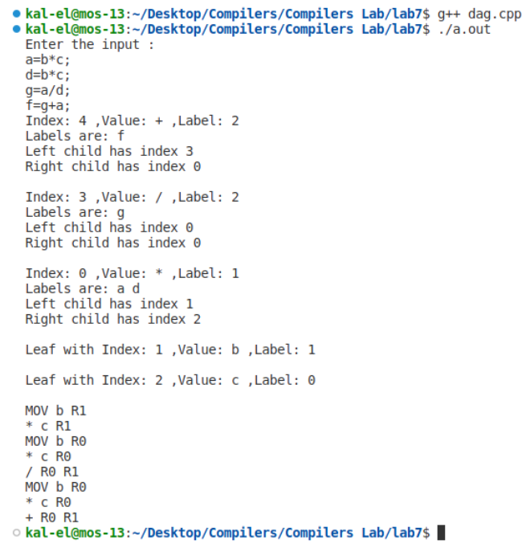

## **Result:**

DAG construction and Simple Code Generation was performed successfully.